Study Notes on Acts 17:1-15
By Joshua M. Weidmann
Friday, February 20, 2015

NOTE: These notes are not intended to read as an article or well-rounded written work. Rather, this is a collage of different research and resources that will assist in the preparation of a sermon.

Working Sermon Title:
To Go Where Complacency Is King

Summary of the Passage:
Paul and Silas minister in Thessalonica and then Berea. In both instances there are many who believe in Jesus followed by a near riot and great opposition. Two key verses…
- “These men who have turned the world upside down have come here also.” (vs. 6b)
- “…they (Bereans) received the word with all eagerness, examining the Scriptures daily to see if these things were so.” (vs. 11)

Outline of the passage:

- vv. 1-3 Paul preaches the Gospel: Jesus is the Christ
- vv. 4 The Gospel was received
- vv. 5-9 The Gospel is opposed
- vv. 10-11 The Gospel considered
- vv. 12 The Gospel accepted
- vv. 13-15 The Gospel hindered

The Main Point of the Passage:
God will send us to places where people don’t want their way of life messed with - they’re comfortable, complacent, and compliant. People rioting against these men who have come to turn their world upside down run Paul Timothy, and Silas out of town twice.

Exegetical Idea: Paul, Silas and Timothy were moving through Macedonia preaching the Gospel as a part of their second journey. While doing so, they faced great opposition but Greeks were still coming to faith in Christ.

Theological Idea: God has a plan that looks different than ours and His purposes will sometimes remain hidden.

Applicational Idea: We can trust that trials and change of plans are all used for God’s purposes, we must remain faithful to God no matter what we face.

Possible Preaching Outline:
- (vv.1-3) When we are called by God we:
  - Look for the best way to fulfill it
  - Stay true to the Gospel of Jesus Christ
  - Understand we are joining God, he is not joining us.
- (vv. 4-9) Faithfulness to God brings on opposition from the World.
  - We remain faithful no matter what they take from us.
  - We trust that God uses earthly barrier to move us toward his purposes.
- (vv 10-15) God works out His purposes through:
  - The willingness of His servants to go where He directs
  - The Power of Scripture to speak truth in dark places
  - Opposition (again) to move us to sovereignly appointed places.

CONTEXT BEFORE AND AFTER THIS PASSAGE:
BEFORE:
- Paul Meets timothy at the beginning of Chapter 16 and they being ministering together after Paul examines him.
- Paul receives a clear vision from the Lord to go to Macedonia:
[9] And a vision appeared to Paul in the night: a man of Macedonia was standing there, urging him and saying, “Come over to Macedonia and help us.” [10] And when Paul had seen the vision, immediately we sought to go on into Macedonia, concluding that God had called us to preach the gospel to them. (Acts 16:9-10 ESV)
- Paul had healed a demon possessed girl and what put in jail for it.
- They were released from jail through an earthquake and were able to bring the prison guard to faith in Christ.

AFTER:
- Paul goes to Athens and finds them worship idols.
- The people (including the philosophers) don not understand his message so they invite him to justify the gospel before Areopagus.
- Paul preaches a sermon against the pagan beliefs of Athens, specifically their “unknown god,” and presents that we can know the one true God.

Exegesis and Commentary:

Introduction:

The Acts of the Apostles covers about 13 years and during that time covers about 13 cities. Thessalonica is one of the few cities that lasted over time and still is a functioning city today—Salonika. It was part of the Great War in 1914-18.

Thessalonica was named after the Macedonian conquest and victory over the Thessalonians. It is a major city because there are three main rivers that converge there and flow into the sea.

[1] Now when they had passed through Amphipolis and Apollonia, they came to Thessalonica, where there was a synagogue of the Jews.

They referred to Paul, Silas and Timothy. They NASB says that they took the road through instead of ESV’s they had passed through. They would have traveled on an important and major thoroughfare through Macedonia. Thessalonica was the most promenade city in Macedonia at the time. It was 62 miles from Philippi.

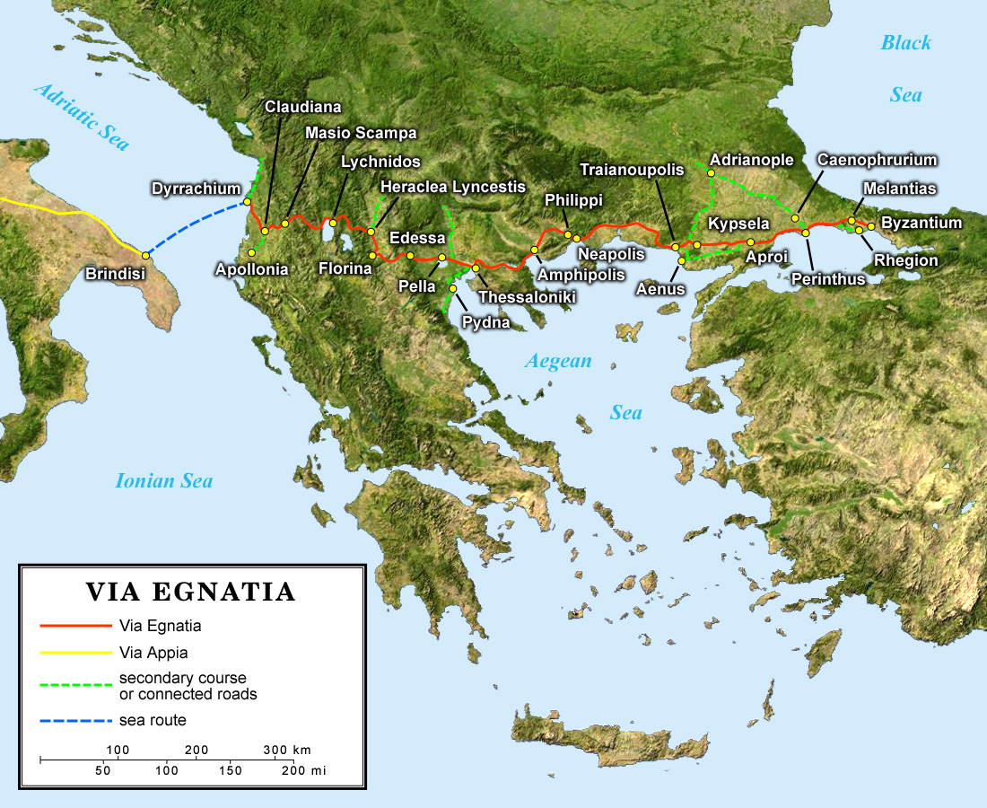

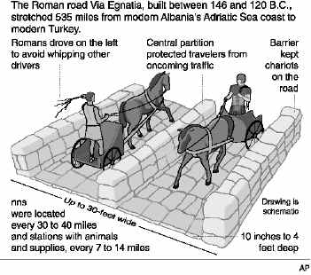
There was a great Roman roadway that traveled southwest through Macedonia and when on to Italy. This was called the Via Egnatia. It began at Neapolis and when through Philippi. Amphipolis, Apollonia and Thesalonica. This would have been the road that this Apostles would have been traveling on, perhaps in hopes to get to Rome.

They went 33 miles from philippi to Amphipolis.

They then went 27 miles to Apollonia.

35 miles to Thessalonica.

If they were to make these distances in a day, they would have traveled by horse instead of simply walking.

We don’t know if they did any ministry of any kind in the first two cities. It doesn’t mention any work that was done there. We also do not have any archeological evidence of synagogues in these towns, so perhaps he just passed through in an effort to get to the capital.

The fact that there was a synagogue in Thessalonica, we can assume that the population was large enough to support this kind of a place. It was made a free city by the Romans in 42 BC.

[2] And Paul went in, as was his custom, and on three Sabbath days he reasoned with them from the Scriptures,

It was [Paul’s] custom to go to the synagogue on the Sabbath because he understood this was a command of God. He would go there to worship by engaging with others in prayer and reading the scriptures. He was speaking from the scriptures, meaning the Old Testament passages that they would have had in the synagogues.

We can also assume that Paul had a sort of evangelistic agenda when visiting the Synagogues. He went to be a speaker of truth with the people he knew he could reason with the most.

We know that he was there for three Sabbaths which tells us that he was there for at least several weeks. He may have been there longer. We know that he received a gift from Philippi wen he was there (Phil. 4:16) and that he longed to stay with the new converts there in Thessalonica (1 Thess. 2:9).

He reasoned with them, meaning the Jewish leaders and those in the synagogue, from the thing they knew the most, the Scriptures. The original word for reasoned is dialectic in the Greek. This suggests a deeper conversation with lots of meaning behind the words; to “open his mouth” and “Explain, reveal, or let light in.” He was using the OT to demonstrate for them the historical data that lead to Christ and proves His messianic validity.

[3] explaining and proving that it was necessary for the Christ to suffer and to rise from the dead, and saying, “This Jesus, whom I proclaim to you, is the Christ.”

We are given only a simple summary statement about the content of Paul’s messages when he was preaching in Thessalonica. Luke saw it fit to only tell us this, with slight allusions to the length of his stay in the previous verse.

The fact that he was explaining and proving that it was necessary for the Christ to suffer would have been hard for them to accept. The Jews rejected Christianity (and still do) on the basis that the Messiah should not have to suffer, but he should rule and reigns like a king.

[3] For I delivered to you as of first importance what I also received: that Christ died for our sins in accordance with the Scriptures, [4] that he was buried, that he was raised on the third day in accordance with the Scriptures, [5] and that he appeared to Cephas, then to the twelve.
(1 Corinthians 15:3-5 ESV)

We know that the Apostles even struggled to believe that Christ would have to suffer, all the way until he was captured and probably even while He was dying. We see this in Matthew 16:21, 22 and Luke 24:25-26.

It is powerful to understand that the main means of his communication was to prove to them the sufficiency of of Christ as the Messiah through Scripture. Surely he may have used reasoning and great oratory skills, but his arguments all came from the Bible.

The fact the he not only suffered but died and rose from the dead would have been hard for them to accept. Yet Paul was making a case that the fact that He rose again proves to us that he is the messiah. It shows the following:
- That he has supernatural origin
- That he has superlative power
- That he has startling omniscience
- That he came to show truth through his words, endorsed by his death and rising again
- He is able to achieve redemption

Paul has assurance, that we too can have, that Jesus was the Christ [Messiah] because of the way that he was prophesied about in Scripture. Paul preaches “in power,” meaning that the Holy Spirit bears witness that this is the true Gospel of God.

[5] because our gospel came to you not only in word, but also in power and in the Holy Spirit and with full conviction. You know what kind of men we proved to be among you for your sake.
(1 Thessalonians 1:5 ESV)

[4] And some of them were persuaded and joined Paul and Silas, as did a great many of the devout Greeks and not a few of the leading women.

A similar thing had happened when Paul was in Galatia and reasoned with them from the Scriptures for the validity of Jesus as the Christ. It is important to note that it was the Greeks (Gentiles) that were being converted and not the Jews.

No matter our background, God has the ability to call us unto Himself. The fact that devout Greeks were putting their faith in Christ showed that this was not just a message for the Jews. Though they were uncircumcised men, they were accepted into the family of faith. Their salvation was not based on an outward adjustment but an inward transformation.

[11] Therefore remember that at one time you Gentiles in the flesh, called “the uncircumcision” by what is called the circumcision, which is made in the flesh by hands—[12] remember that you were at that time separated from Christ, alienated from the commonwealth of Israel and strangers to the covenants of promise, having no hope and without God in the world. [13] But now in Christ Jesus you who once were far off have been brought near by the blood of Christ.
(Ephesians 2:11-13 ESV)

It is interesting that the high women are mentioned here. This shows that the Gospel was for all people. These women of influence were probably Macedonians that had come to faith. They had the ability to influence others to believe in the truth of Christ. Macedonian women had a well-earned reputation for their independence and enterprising spirit. This also would have shown the right for women to believe in something whether the husbands believed or not.

The Gospel seemed to be accepted and have immediate power. There was no delay in saving those who believed. This would have brought great joy to Paul.

[13] And we also thank God constantly for this, that when you received the word of God, which you heard from us, you accepted it not as the word of men but as what it really is, the word of God, which is at work in you believers.
(1 Thessalonians 2:13 ESV)

The fact that they were persuaded shows the work of the Spirit in their lives and through the words of Paul and Silas.

The idea of them receiving the word of God is more than accepting it as intellectual truth. This meant that they received the Gospel in a manner that it affected the way that they lived.

[1] Finally, then, brothers, we ask and urge you in the Lord Jesus, that as you received from us how you ought to walk and to please God, just as you are doing, that you do so more and more. (1 Thessalonians 4:1 ESV)

The Gospel seems to have three clear results here in this passage:
- Faith of the people (v.4)
- Fellowship as they joined Paul and Silas and became a part of the growing family of God (v. 4)
- Fortitude rose as those that were opposed to them tried to kill and attack. The gospel of Jesus has an emboldening effect.

[5] But the Jews were jealous, and taking some wicked men of the rabble, they formed a mob, set the city in an uproar, and attacked the house of Jason, seeking to bring them out to the crowd.

Once again in the book of Acts we see the jealousy of the Jews rise against the Apostles (cf. 13:45, 50; 14:5; 19). They didn’t like to see the way that Paul was continually earning the favor of the people and their belief in the Gospel. Paul also wrote to the Thessalonians:

[14] For you, brothers, became imitators of the churches of God in Christ Jesus that are in Judea. For you suffered the same things from your own countrymen as they did from the Jews, [15] who killed both the Lord Jesus and the prophets, and drove us out, and displease God and oppose all mankind [16] by hindering us from speaking to the Gentiles that they might be saved—so as always to fill up the measure of their sins. But wrath has come upon them at last!
(1 Thessalonians 2:14-16 ESV)

Most likely it would have been the Jewish leaders that stirred the people to go against the Apostles.

Some scholars believe that the Thessalonians were lazy and easily persuaded people because of passages like this:

[10] For even when we were with you, we would give you this command: If anyone is not willing to work, let him not eat. [11] For we hear that some among you walk in idleness, not busy at work, but busybodies. [12] Now such persons we command and encourage in the Lord Jesus Christ to do their work quietly and to earn their own living.
(2 Thessalonians 3:10-12 ESV)

The laziness of the people would have been a tool for Jewish leaders to use to move the people against Paul and Silas – “Get up and join us as we take out these rebels!”

[6] And when they could not find them, they dragged Jason and some of the brothers before the city authorities, shouting, “These men who have turned the world upside down have come here also,

They started at the house of Jason when hunting to capture the Apostles. This is where they were staying, but they were not there when the antagonizing Jews arrived.

Jason is the Greek version of the Hebrew name, “Joshua.” There is a Jason that is mentioned in Romans 16:21 and some believe this is the same guy, though we cannot be sure. If it were the same one, he was a Christian from Corinth.

When they could not find the Apostles they decided to make a spectacle of those who had helped them or sided with them. They wanted to make sure everyone knew that they opposed the Apostles and all those that went with them or believed what they had to say. Jason and the other new Christians were taken out and persecuted for their faith and affiliation with Paul, Timothy and Silas.

They charged them with turning the world upside down. While this is a bit dramatic, there is great irony about this statement. They were pledging their allegiance to the one true King, Jesus, and this was turning the ancient religious world upside down. Another way to say this is that they were seditious, mutinous and treasonable.

They were not on a mission to get the people to revolt against the King, but the slightest hint of this would be cause for authorities to take action to arrest or execute the Apostles. Remember, it was under a similar charge that Jesus was sent to death.

[7] and Jason has received them, and they are all acting against the decrees of Caesar, saying that there is another king, Jesus.”

The Jews were using the lack of spiritual perspective they had and others maintained that spiritual kingship and earthly kingship are two different things. They were going to convince the people that Paul really was committing treason. This was not a new accusation – Jesus Himself was accused of this in Luke 23:1-5 and John 18:28-40.

[8] And the people and the city authorities were disturbed when they heard these things. [9] And when they had taken money as security from Jason and the rest, they let them go.

This means that they took bail for them and then released them.

Paul gives a summary of the Thessalonian Christians in 1 Thessalonians 1:3-10:

[3] remembering before our God and Father your work of faith and labor of love and steadfastness of hope in our Lord Jesus Christ. [4] For we know, brothers loved by God, that he has chosen you, [5] because our gospel came to you not only in word, but also in power and in the Holy Spirit and with full conviction. You know what kind of men we proved to be among you for your sake. [6] And you became imitators of us and of the Lord, for you received the word in much affliction, with the joy of the Holy Spirit, [7] so that you became an example to all the believers in Macedonia and in Achaia. [8] For not only has the word of the Lord sounded forth from you in Macedonia and Achaia, but your faith in God has gone forth everywhere, so that we need not say anything. [9] For they themselves report concerning us the kind of reception we had among you, and how you turned to God from idols to serve the living and true God, [10] and to wait for his Son from heaven, whom he raised from the dead, Jesus who delivers us from the wrath to come. (1 Thessalonians 1:3-10 ESV)

Paul was probably struggling over the fact that they had to leave, but there was no choice. The opposition had grown too thick that it was now hindering the growth of the new converts. He had to go. We also know that he wrote later and saying that “Satan had kept them from returning” (1 Thess 2:18). He cared for the people but the opposition was just too much to overcome. He may have seen the opposition as satanic workmanship and the spiritual hurdle to their greater good.

Nonetheless, the new church was facing grave persecution early in its life. Yet it maintained faith in the face of opposition. They also remained a faithful witness to God’s grace and mercy to sustain what he had started.

[10] The brothers immediately sent Paul and Silas away by night to Berea, and when they arrived they went into the Jewish synagogue.

When the trouble was getting worse in Thessalonica, the Christian brothers chose to send Paul and Silas to Berea which was about fifty miles to the southwest. This city is now called Veria. Supposedly there are more than seventy hidden churches still in that city that has been around since the Turkish persecution of Greek Christians.

ILL: There is a modern park there that has a small podium entitles “St. Paul’s Pulpit” which could be referring back to what happened in these verses.

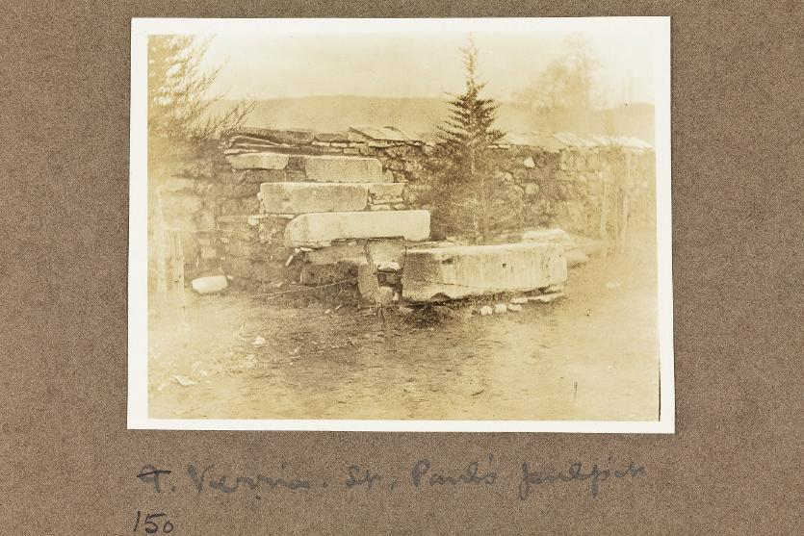

Instead of continuing their pathway to the southwest, it was best for them to head straight south to Berea. He may have wanted to go to Rome but instead was directed south because of the hostility that he found in Thessalonica. We know that he had said it was hi intent to get to Rome far earlier than he actually did in Romans 1:13 and Romans 15:22. Though this was different than he would have planned, it could be that this was God’s plan all along.

Cicero described Berea as an “Out of the way town.” It was the first city to of Macedonia to surrender to the Romans at the end of the Third Macedonian War in 168 BC.

[11] Now these Jews were more noble than those in Thessalonica; they received the word with all eagerness, examining the Scriptures daily to see if these things were so.

When Luke says that the Jews were more noble he was not meaning that they were better in character (though that seems to be the case) but they were literally more noble by birth.

They also showed a readiness of mind to receive what it was that Paul and Silas had to say – this is translated as an eagerness.

[11] So now finish doing it as well, so that your readiness in desiring it may be matched by your completing it out of what you have. (2 Corinthians 8:11 ESV)

Of all the Bereans that accepted the truth, we know that there was a man named Sopater son of Pyrrhus mentioned in Acts 20:4.

[12] Many of them therefore believed, with not a few Greek women of high standing as well as men.

There were many that believed in the Gospel, truly injesting it as truth and moving to action. Their reverence for the Word of God [Scripture] led to a reliance on the Word of God, which gave way to a reception of the Gospel and a reproduction of it in others. See also Psalm 19:7-14 and John 5:46.

Again we see that man of the women believed and are mentioned here as well as the fact that men believed as well.

[13] But when the Jews from Thessalonica learned that the word of God was proclaimed by Paul at Berea also, they came there too, agitating and stirring up the crowds.

The peace and acceptance of the Gospel did not last long as they may have hoped; it was only a matter of time before the opposing Jews came from Thessalonica to turn the people against the Apostles. They were determined to stop them at all costs. They were going to use the ignorance and prejudice of the people to turn them against Paul and Silas.

This happened earlier in acts when the antagonizing Jews came from Antioch and Iconium to Lystera to stir up the crowds against the apostles. Now the Jews of Thessalonica came nearly 60 miles to stir up the people in Berea.

[14] Then the brothers immediately sent Paul off on his way to the sea, but Silas and Timothy remained there.

[1] Therefore when we could bear it no longer, we were willing to be left behind at Athens alone, [2] and we sent Timothy, our brother and God's coworker in the gospel of Christ, to establish and exhort you in your faith, (1 Thessalonians 3:1-2 ESV)

Because of the conflict that was on the rise, the brothers took Paul to send him off while Silas and Timothy were left behind to minister to the church and the new converts in Berea and Thessalonica. The took Paul to the sea-coast to send him to Athens.

The assumed that if the mouthpiece and main leader in Paul was removed it would be easier to minister to the people. This is intriguing; sometimes God has to move his main speakers to that the other work of the ministry can be done without distraction.

The Bereans and Timothy and Silas rejoined Paul later in Berea.

[15] Those who conducted Paul brought him as far as Athens, and after receiving a command for Silas and Timothy to come to him as soon as possible, they departed.

Because Paul was the main target of the Jews contempt, the Christian brothers took Paul to Methone and Dium, the coast to send him on a ship to the port of Athens, Piraeus.

See W.W. Tarn and G.T. Griffith, Hellenistic Civilization (London, 1952) pp.98-99.

