Study Notes on Acts 12:20-25
By Joshua M. Weidmann
Saturday, November 22, 2014

NOTE: These notes are not intended to read as an article or well-rounded written work. Rather, this is a collage of different research and resources that will assist in the preparation of a sermon.

Working Sermon Title: Redefine Greatness

Summary of the Passage: Herod has grown in his pride as he persecutes Christians. Upon giving a speech to the people and accepting their praise, God struck him dead.

The Main Point of the Passage:

Exegetical Idea: Luke is recounting the death of Herod and the way he did not give glory to God so his life was taken from him.

Theological Idea: We should have no other God’s beside the one true God (including ourselves).

Applicational Idea: God gives grace to the humble and opposes the proud; we must strive to have humility if we are going to have more of the presence of God in our lives.

SIMILAR PASSAGES IN SCRIPTURE:

1 Peter 5:5, “God opposes the proud and gives grace to the humble.”

CONTEXT BEFORE AND AFTER THIS PASSAGE:

Chapter 12 is telling the story of the early church from Jerusalem being persecuted. This is the last chapter we have that tells us about the early church without mention of Saul.

After he had Herod had killed James he was on a hunt for Peter. He locked Peter up and was proud of it, so he was mad when God helped him escape.

Herod was very upset, so he instituted a search for Peter. In his anger, and perhaps to get away from the stress of fighting with the Christians, he went to Caesarea—a predominantly Roman city with Jewish influence.

Exegesis and Commentary:

[20] Now Herod was angry with the people of Tyre and Sidon, and they came to him with one accord, and having persuaded Blastus, the king's chamberlain, they asked for peace, because their country depended on the king's country for food.

Herod
This chapter begins and ends with Herod. This would have been Herod Agrippa I. We know that he was a major persecutor of the church and in this chapter we see him punished by death for opposing God’s people. Other things we know about him:
- Herod Agrippa I live 11 BC – 44 AD.
- He was also known as Herod or Agrippa I.
- He was a Judean monarch during the 1st century AD.
- He is the grandson of Herod the Great and son of Aristobulus IV (Herod’s son) and Berenice, he was born Marcus Julius Agrippa, so named in honour of Roman statesman Marcus Vipsanius Agrippa.
- He is the ruling king named Herod in the Acts of the Apostles, "Herod (Agrippa)" (Ἡρώδης Ἀγρίππας).
- He was, according to Josephus, known in his time as "Agrippa the Great".
- Christian and Jewish historiography takes different views of this king, with the Christians largely opposing Agrippa and the Jews largely favoring Agrippa.
- By his wife Cypros he had a son and three daughters.
- His son, Herod Agrippa II [b.27/28 AD?-d.93 AD?] became the seventh and final king from the Herodian family.

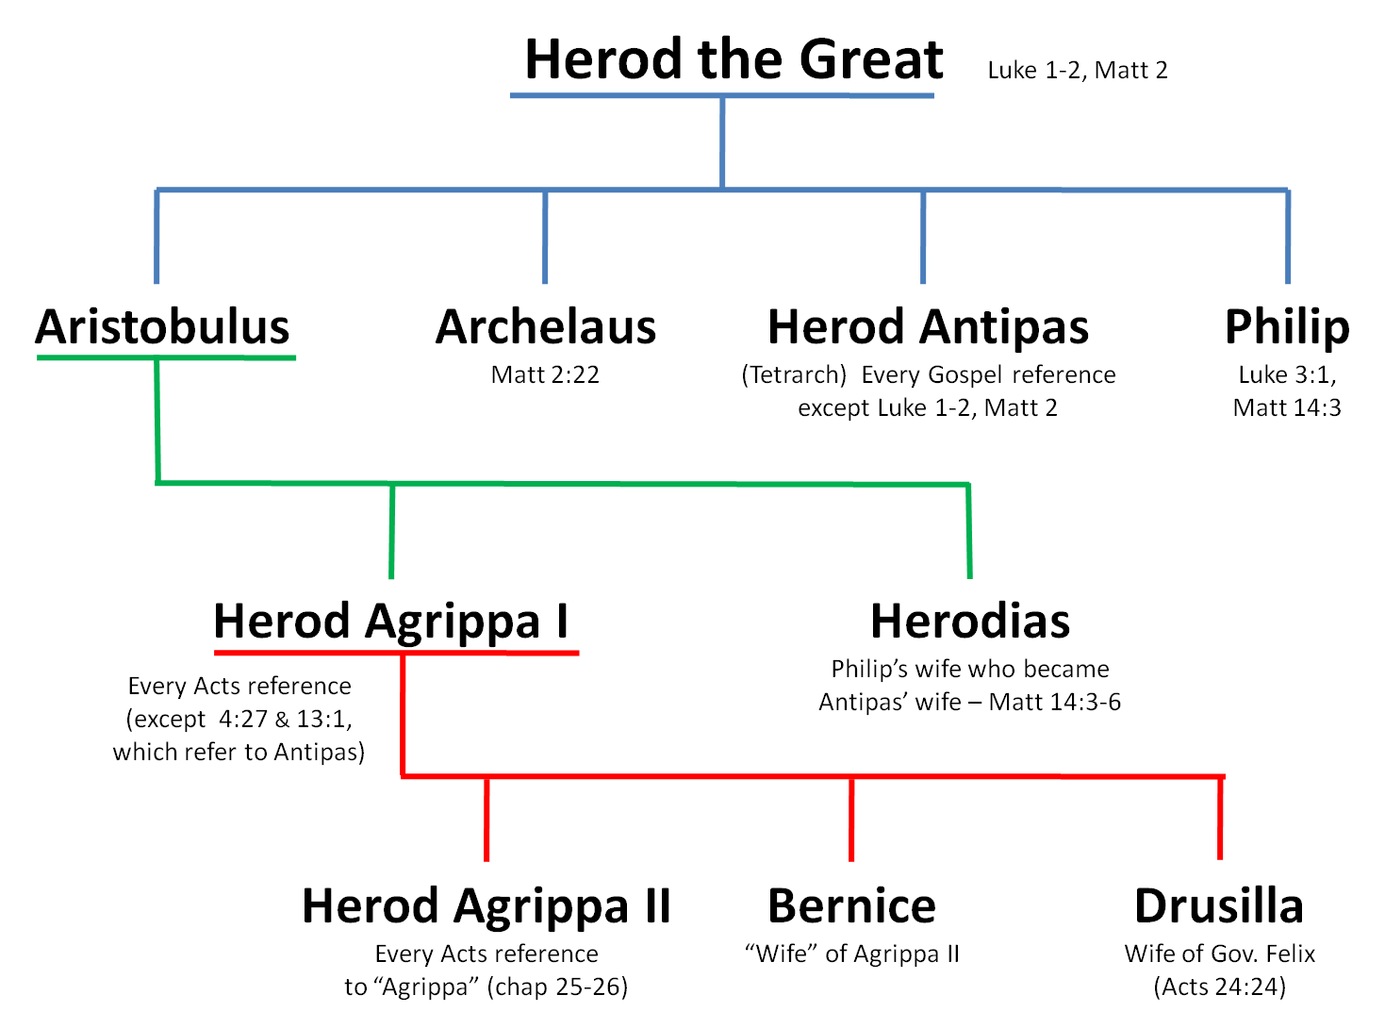

"King Herod" mentioned in Acts is identified by historians as the same person as Herod Agrippa. The identification is based in part on the description of his death, which is very similar to Agrippa's death in Josephus's Antiquities of the Jews 19.8.2.344-350, although Josephus does not include the claim that "an angel of the Lord struck him down, and he was eaten by worms." Further evidence is the identification of the ruler in Acts 12:1 as "Herod the king," since Agrippa is the only Herod who would have had authority in Jerusalem at that time.

The description of Herod Agrippa as a cruel, heartless king who persecuted the Jerusalem church, having James son of Zebedee killed and imprisoning Peter, stands in contrast with Josephus' account of a kindly ruler. This is likely because the Bible gives the Christian account and Josephus was a Jewish man; the Jews favored Herod Agrippa. Christian scholars argue that the biblical account makes sense given that Agrippa had been raised with a strong Jewish identity. Agrippa would resent a movement begun during his absence from Judea that tried to declare a man as divine.

The People of Tyre and Sidon
This passage mentioned that Herod was angry at the people of Tyre and Sidon. We know this following about Tyre and Sidon:
- They were coastal cities
- They were free self-governing cities
- They were economically independent from Judea

We don’t know what they were quarrelling about with Herod, but we know that it made him very angry. Hey were looking for peace. They relied on Judea—specifically Galiee—for food, so this was obviously of great importance to Tyre and Sidon.

They came to Him with one accord means that were in unity in their desperation and approach. They knew they needed to get to the king and “no” was not an option. The way they finally got to the kind was by persuading Blastus, the king’s Chamberlain, to let them in. A chamberlain is an officer who manages the household of a monarch or noble; the Greek literally means “the one over the bedroom,” but such a person would have had wider responsibilities than this. He would have been the mediator they needed to get in front of the king. Sure enough, by the next verse we can see they were granted an audience with the king. Their agenda would have been to make peace with him quickly and publically.

[21] On an appointed day Herod put on his royal robes, took his seat upon the throne, and delivered an oration to them.

We are indebted to Josephus for the great account that he gave of this exact story. He records various details that are not given in the scripture, but can be verified through concrete detail that this is the same story (i.e. Herod’s death).

Agrippa was holding festivals in celebration of the Emperor Caesar. He would have conducted many “Shows and Festivals” according to Josephus. There would have many people gathered to see these shows, and most likely, the appearance with the royal robes would have been at one of these gatherings. The two possible dates for this kind of gathering to celebrate Caesar could have been:
- Around March 5th in honor of the foundation of Caesar (Die Natalis)
- Around August 1, which was Caesar’s birthday

The festivals would have gathered all sorts of people, including officials and others in distinguished positions.

On the second day of the one of the festivals, the appointed day for Tyre and Sidon to be there, Herod put on a royal robe. Josephus tells us in 19.8.344 that he “put on a garment made wholly of silver, and a contexture truly wonderful. And came in to the theatre early in the morning; at which time the garment being illuminated by the fresh reflection of the sun’s rays upon it, shown out after a surprising manner, and was so resplendent as to spread horror over those that looked intently upon him; and presently his flatterers cried out from one place, and another from another (though not for his good), that he was a god; and they added, “be thou merciful upon us; for although we have hitherto reverenced the only as a man, yet shall we henceforth own thee as superior to mortal nature.’ ”

[22] And the people were shouting, “The voice of a god, and not of a man!”

No doubt these words were complete flattery. They also were superstitious in nature, as the coat glowed in the sunshine they were sure he was appearing as a god. Josephus goes on to say that Herod heard this and “upon this the kind did not neither rebuke them, nor did he reject their impious flattery.”

[23] Immediately an angel of the Lord struck him down, because he did not give God the glory, and he was eaten by worms and breathed his last.

The difference between Josephus’ account and Luke’s accout of this story is the presence of an owl and an angel. Luke says that “an angel of the Lord” struck him dead. Though Josephus does not record this, he does record the following:

“Soon afterward [not rebuking the crowd for their flattery] he looked up and saw an owl sitting on a rope above his head, and recognized it as once as a messenger of evil as on a former occasion it has been a messenger of good; and a pang of grief pierced his heart.”

The story of the earlier instance in which Agrippa would have seen this owl is recorded by Josephus in 18.195-201. When Agrippa was thrown into chains year prior, by Tiberius, he leaded against a tree in the pain of his grief. In that tree an owl sat (the romans called owls “Bird Bubo”). A German fellow-prisoner, saw him and asked to be released to go speak with him. In doing so he gave a sort of prophecy that he would be released from his present pain and that his life would prosper and he would reach a pinnacle of wealth, power and happiness. Yet, he said that if he sees this bird that is in the tree again he would have but five days to live.

Truly, Herod Agrippa would have been at a pinnacle of wealth, power and happiness at the end of Acts 12. When he saw the same owl, he remembered the prophecy of the German prisoner. Certainly his predictions had been true so far, so to see the owl again he could only assume in fear that it was the statement of his impending death in five days.

Sure enough, Josephus tells us that he immediately had severe pain in his stomach and bowels that increased in intensity. He suffered for five days with pain in his belly. On the last day he heard the cries of the people still worshiping and now grieving him as if he was a god. With that, he took his last breathe in his last breath. He was fifty-four years old and in the seventh year of his kingship. ^{Josephus Ant. 19.343-350}

We can assume that Luke’s statement “eaten by worms” could be the explanation given for the pain in his gut. It could also be a statement of the decay of death that happened; God took his life from Him, he was now powerless.

Luke gives us the clear and biblical reason that this happened: Because he did not give glory to God.

It stands out to me that God was still taking people out that did not give him glory. Just as he did with King Neb, so he also did with Herod, but to death. God will take out anyone that is giving credit to himself more than God. I’ve seen that with James MacDonald, Mark Driscoll, Bob Coy etc. If we do not give God the credit, He has no problem removing us or humbling us.

Herod’s actions can be contrast to Peter’s instantaneous rejection of worship by the Centurion in 10:26; Herod receives this wrongful praise with delight. In both cases the instinctive response to an unexpected situation revealed the condition of the man’s heart.

[5] Likewise, you who are younger, be subject to the elders. Clothe yourselves, all of you, with humility toward one another, for “God opposes the proud but gives grace to the humble.” (1 Peter 5:5 ESV)

[24] But the word of God increased and multiplied.

This is a brief report that the Church was still growing, despite the opposition. We have similar statements in 6:7 and 9:31.

This is a clear statement of contrast between the gross death of Herod and the glorious spread of the Gospel.

[25] And Barnabas and Saul returned from Jerusalem when they had completed their service, bringing with them John, whose other name was Mark.

This passage simply sets the scene for the next passage.

Now these key leaders are back in Antioch. The only real connection is that while they were gone on their journey, Agrippa died.

This statement is a transition statement or connecting phrase to 11:30 where they go to Jerusalem and then in 13:1 are in Antioch again.

The reference to John/Mark is a connection of the fact that in 12:12 he was in Jerusalem and now in 13(5b) he is with Saul and Barnabas in Antioch. We know that Mark was Barnaba’s cousin by the passing remark we have about him in Col. 4:10.

